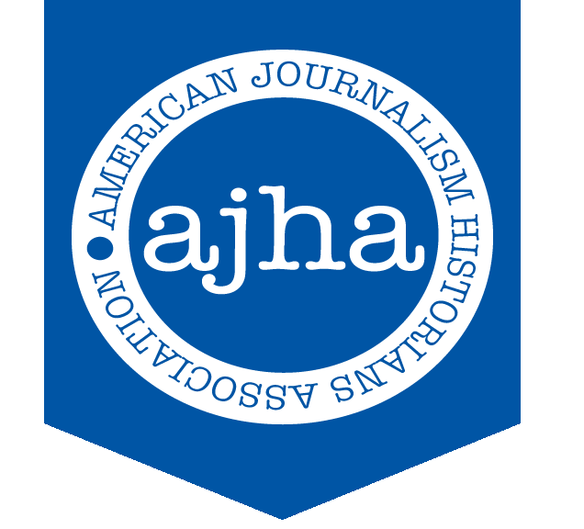
PRESS RELEASE
Aug. 26, 2019
For Immediate Release
Contact: Willie R. Tubbs
Phone: (225) 936-8565
Email: wtubbs@uwf.edu
Written by Willie R. Tubbs

Utah’s Vergobbi wins AJHA Teaching Award
David James Vergobbi of the University of Utah is the winner of the 2019 Award for Excellence in Teaching, the education committee of the American Journalism Historians Association has announced.

Vergobbi has been on faculty at the University of Utah since 1992, having previously completed his Ph.D. at the University of Washington.

“Receiving this award from AJHA is a capstone point in my career,” Vergobbi said. “Getting the award never occurred to me. This unexpected pleasure is due to the efforts of Erika Pribanic-Smith of UT-Arlington, who did the work of nomination, and my Utah colleagues Kim Mangun and Glen Feighery, who supported the nomination process.

“It is their belief in me that made this possible and I'm deeply grateful to them. Fittingly, they remind us that belief-in-others is the essence of effective teaching. Recipients of such belief push beyond their imagined limits. Thank you for this continuing lesson, Erika, Kim and Glen. And thank you very much AJHA. I admit emotion overcame me when Education Chair Kaylene Armstrong told me the good news.”

AJHA’s education committee members noted Vergobbi’s sustained excellence in all areas of teaching as well as a commitment to involvement and interaction as cornerstones of the courses he’s taught.
“After teaching for years, I came across a proverb scribbled on the wall of my daughter's pre-school room that captured, and continues to guide, my pedagogy: 'Tell me, I'll forget. Show me, I might remember. Involve me, I'll understand,'" Vergobbi said. "Involvement, interaction, passionate expertise, high expectations, authenticity and fun can even overcome digital temptations. And if that doesn't work, sing.”
Vergobbi will be officially recognized during the 38th Annual AJHA Convention, which is scheduled for Oct. 3-5 in Dallas.

The Award for Excellence in Teaching is given annually to the college or university teacher who excels at teaching in areas of journalism and mass communication history.

Founded in 1981, the American Journalism Historians Association seeks to advance education and research in mass communication history. Members work to raise historical standards and ensure that all scholars and students recognize the vast importance of media history and apply this knowledge to the advancement of society. For more information on AJHA, visit http://www.ajhaonline.org.

###

