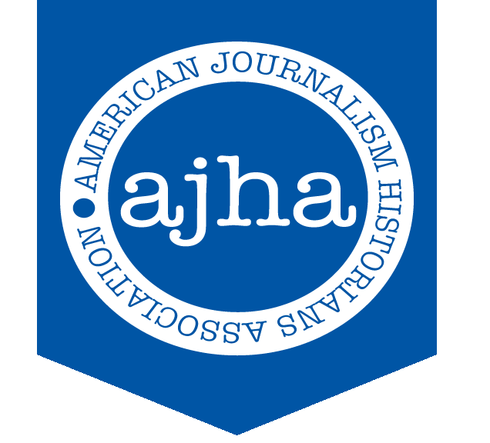
PRESS RELEASE
Aug. 21, 2019
For Immediate Release
Contact: Willie R. Tubbs
Phone: (225) 936-8565
Email: wtubbs@uwf.edu
Written by Willie R. Tubbs

Mislán named 2019 AJHA Rising Scholar Award Winner

The editors of American Journalism, the peer-reviewed quarterly journal of the American Journalism Historians Association, have announced Dr. Cristina Mislán of the Missouri School of Journalism as this year’s AJHA Rising Scholar award winner.

The Rising Scholar honoree is chosen annually by the editors of American Journalism. The award is designed for scholars who show promise in extending their research agendas.

Mislán is currently working on a book that will address a unique angle of coverage of the Cuban Revolution.

“I am honored to receive the 2019 Rising Scholar Award,” Mislán said. “This award will allow me to complete my first book, which analyzes how Black journalists, writers, publishers, and editors imagined the Cuban Revolution of 1959. In taking a deep dive into approximately six decades of media coverage, I hope to join a growing group of scholars who have provided indispensable insight into the critical role that the Black press played in shaping this nation’s history.”

Mislán expressed thanks to the entirety of AJHA.

“I've found AJHA members to be supportive, collegial and inclusive colleagues as well as wonderful scholars,” Mislán said. “Thank you AJHA for your support! I will use this award wisely and well."

Mislán will be formally recognized during the 38th Annual AJHA Convention, which will be held Oct. 3-5 in Dallas.

Founded in 1981, the American Journalism Historians Association seeks to advance education and research in mass communication history. Members work to raise historical standards and ensure that all scholars and students recognize the vast importance of media history and apply this knowledge to the advancement of society.

For more information on AJHA, visit http://www.ajhaonline.org.

###

